Rates :
- Administrative fee, for room use and pianist: 90 euros (non-refundable, to be paid on enrolling, by cheque to the order of « L’A S M » or bank transfer)
- Teaching fees: 280 euros, to be paid directly to the teacher.
- Accommodation costs: homestay recommended (comfortable and close!): 120 euros for six nights, breakfast included (20 euros a night … ) payable to « L’ASM »
- Meals: a tariff of 91 euros payable to « L’ASM » has been negotiated for seven meals where both students and teachers will dine together.

Instrumental lessons :
Tuesday 5th February 2:00pm.
to Monday 11th February 2019, midday.

Office and postal address of
L’Art-Scène-Montpellier,
Association Loi 1901 :
4 rue de la cavalerie, 34000 Montpellier-France
Phone; +33(0)686282517
friedrich.alber@gmail.com

Piano accompaniment:
Sylvaine Nelly and Paisit Bon-Dansac

Enrollment form :
To send back as soon as possible (the number of places is limited!) to Friedrich ALBER, luthier, 4 rue de la Cavalerie, 34000 Montpellier, accompanied by a cheque of 90 euros to the order of « L’A S M » for the administrative fee.
Name: First Name:
Address:
Postal Code: City:
Phone: Email:
Date of Birth:
Nationality:
Instrument:
Playing Level:
Music School attended:
Option chosen; (7 meals at 91 euros) : YES / NO (delete an option)
Homestay accomodation (20 euros/night) : YES / NO (delete an option)
For the participants who are minors:
Name and first name of legal guardian:
Address (if different from that mentioned above):
Postal Code: City:
Phone:
Date: Signature:

(Legal guardian if a minor)
Please attach a parental authorisation for any underage participant.

7th WINTER MASTER-CLASSES
Violin, viola and cello
5th to 11th February 2019
Montpellier
Five individual lessons with distinguished teachers, competition preparation, musical meetings, and public student concert.
Maison des Chœurs and
Maison pour tous Frédéric Chopin

(in collaboration with the CRR de Montpellier)

Further information:
L’Art-Scène-Montpellier
Tel. 06 86 28 25 17
friedrich.alber@gmail.com
www.falber.fr
the teachers
Pierre-Henri Xuereb, viola
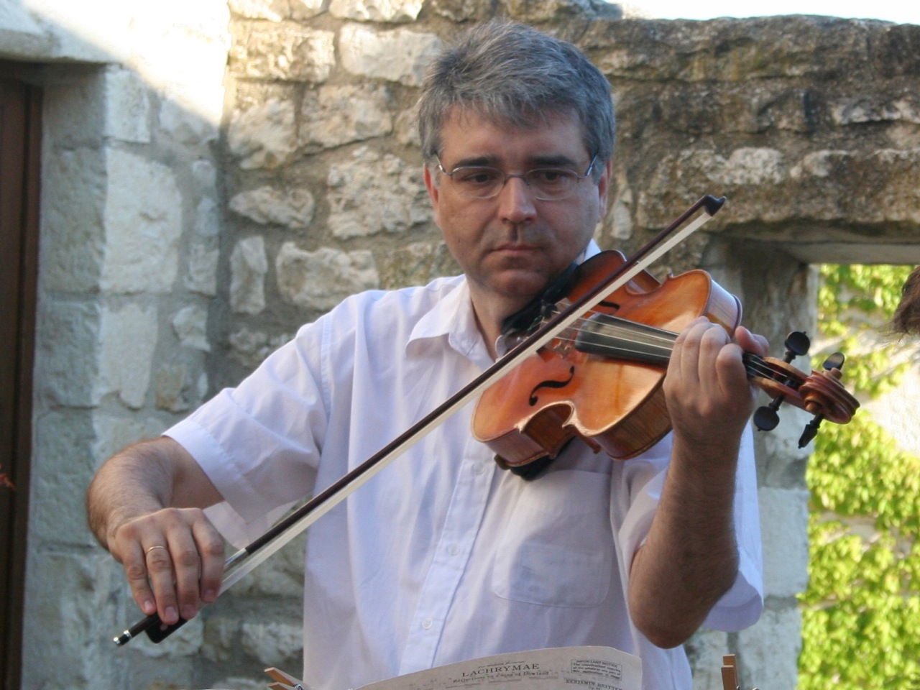

After receiving a first prize in viola from the Conservatoire in Avignon at the age of 13 Pierre-Henri Xuereb received a first prize in viola from the CNSM in Paris at the age of 16. After two years each at the Juilliard School and at Boston University where his teachers were Walter Trampler, Lillian Fuchs, and the Juilliard Quartet, he became Solo Viola of the Ensemble Intercontemporain in Paris conducted by Pierre Boulez at the age of 19. In the winter of 1981 he was one of the last students of William Primrose (Provo-Utah).
Since then his international career has developed taking him to many concert halls throughout the world: the Lincoln Center, Wigmore Hall, Théatre des Champs Elysées, Teatro La Scala (Milan), Gulbenkian Foudation (Lisbon), Luzern Festival…
He has performed as a soloist with the Ensemble Instrumental de France, Ensemble Intercontemporain, Ensemble Alternance, Ensemble Contrechamps, Orchestre Symphonique de Tel Aviv, Israel Sinfonietta, Orchestre OLRAP, Orchestre Paca, Caracas Chamber Orchestra ,Victoria Symphony (Canada), Prussian Chamber Orchestra, Dusan Skovran Orchestra( Belgrade)…
He is regularly invited to give international masterclasses in Beijing, Kyoto, Gwangju (Korea) Tignes (Musicalp), Les Arcs, Fontainebleau, Close Encounters…(Berkshires, USA), Novisad, Malta, Domaine Forget (Canada)…
He recently created a new chamber ensemble, The Primrose Ensemble. He is Artistic Director of the Fête de l’alto in Lasalle (Cevennes) and in August 2018 he started a new concert series Musiques et Paroles à Vouland in the Musée Vouland, Avignon.
He teaches viola at the CNSM in Paris, the Conservatoire Royal de musique de Liège and the CRD in Gennevilliers. He has recorded over 70 discs and recently recorded, under the direction of the composer, Vladimir Cosma’s Viola Concerto which was written for him. His viola is made by Friedrich Alber (Montpellier). He plays viola d’amore and appears regularly in concert and recordings with his wonderful instrument built by Michiel de Hoog in 1995 (copy of Stradivarius).

Philip Bride, violin
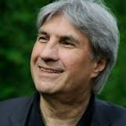

Philip Bride began learning the violin at the age of four. He won a first prize in violin by unanimous decision while in the class of René Benedetti, and also a first prize in chamber music when in the class of Maurice Crut at the CNSMD de Paris. He also studied harmony and conterpoint there in Henri Challan’s class, and was also a student of Gérard Poulet and Henryk Szeryng. He studied equally
In New York with Zino Francescatti becoming one of his most representative disciples.
After four years as a first violinist in the Orchestre de Paris, he became concertmaster of the Orchestre de chambre de Paris.
Philip Bride succeeded Jean-Pierre-Wallez as Musical Director of the Ensemble instrumental de France.
Since 1991 he has been Director of the Conservatoire national à rayonnement régional de Marseille where he runs a master-class in violin. Equally, he is a violin teacher the Schola Cantorum in Paris.
Pauline Bartissol, cello
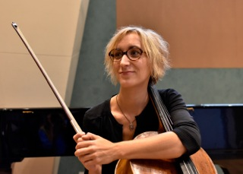
A graduate of both the Conservatoire National Supérieur de Musique de Paris and the MusikHochschule in Cologne (Germany), Pauline Bartissol's eclectic cello practice is driven by her creative curiosity and her taste for artistic and human exchange.
Associate Principal Cello of the Orchestre Philarmonique de Radio-France since 2007, she has also held an assistant professor position at the Paris CNSM since September 2013 (Class of Marc Coppey).
She regularly plays chamber works in festivals (Musical Quinzena in San Sebastian, Bilbao and Vitoria Festival, Juventus Festival, Heures musicales at the Musée d'Orsay, Return Festival in Erevan...) and also explores other repertoire in her duo with jazz saxophonist Jean-Charles Richard and within Salzedo, a trio she founded in 2005 with flutist Marine Pérez and harpist Frédérique Cambreling.
A formation focused on rare and demanding chamber music, the Salzedo trio distinguishes itself by the interdisciplinarity of its projects — wether it's with performance or visual artists, most recently through a collaboration with Jean-François Stöerkel —
and of its repertoire (R.Nillni in 2015, J.Magrané-Figuera in 2017). Since 2002 she has taught at the CRR de Toulouse, in collaboration with Philippe Muller, and at the Conservatoire Municipal du 13ème Arrondissement de Paris, the Centre d’Etudes Supérieures de Toulouse, and at the CEFEDEM de Bordeaux-Aquitaine.

Hagai Shaham, violin
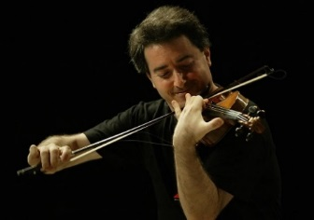

Displaying a dazzling combination of technical brilliance and a uniquely profound musical personality, Hagai Shaham is internationally recognized as one of the astonishing young violinists who has emerged from Israel in recent years. Hagai Shaham began studying the violin at the age of six and was the last student of the renowned late Professor Ilona Feher. He also studied with Elisha Kagan, Emanuel Borok, Arnold Steinhardt and the Guarneri Quartet. In September 1990, Hagai Shaham and his duo partner, Arnon Erez, won the first prize at the ARD International Music Competition in Munich in the Violin-Piano duo category, the first competitors to be awarded this coveted first prize since 1971. His other awards include first prizes at the Ilona Kornhouser Competition, the Israeli Broadcasting Authority Young Artist competition, The Tel-Aviv Rubin Academy competition, four Clairmont Awards, and an annual scholarship from the American-Israel Cultural Foundation. As a soloist he has performed with many of the world's major orchestras; in 1985 he was invited to join Isaac Stern and Pinchas Zukerman in a gala concert at Carnegie Hall, following which Zubin Mehta invited him to perform Brahms' Double Concerto at Carnegie Hall. In 2006 he performed once again this work under Mehta, at the Israel Philharmonic 70th anniversary's celebrations with cellist Misha Maisky. He is in great demand as recitalist. He regularly tours throughout Europe, North and Central America performing at international recital series and festivals. He is a professor at the Buchmann-Mehta School of Music at Tel Aviv University. His Master-Classes in Europe and Israel attract many students. Together with his colleague, violinist Ittai Shapira, he is co-founder of The Ilona Feher Foundation.

